# .NET Queations and Answers

**[Write Examples and Syntax for Every Question]**

## 2 Marks

1. Define web technology

Web technology is a way for computers to communicate with each other using multimedia packages and markup languages. It allows users to interact with hosted information, such as website.

* Web technology involves the use of:
* HTML (Hypertext Markup Language)
* CSS (Cascading Style Sheets)
* JavaScript
* HTTP (Hypertext Transfer Protocol)
* Web browsers are software applications that allow users to access and view web pages on the internet. They play a crucial role in interpreting and rendering the HTML, CSS, and JavaScript codes of web pages.

1. Sample program in html with output design.

HTML Code:

<html>

<head>

<title>Demo Design</title>

</head>

<body>

<h1>Simple Design</h1>

<p>A small paragraph</p>

</body>

</html>

Design:

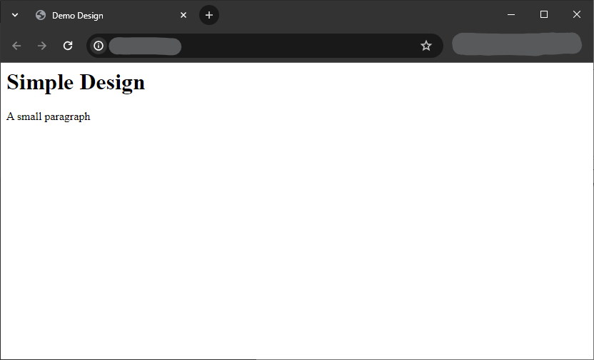

1. Client side technology

In web development, the client side refers to everything in a web application that is displayed or takes place on the client (end user device). This includes what the user sees, such as text, images, and the rest of the UI, along with any actions that an application performs within the user's browser.

(OR)

Client-side technologies are tools and languages that run in a user's web browser, rather than on a web server. Client-side code is written using HTML, CSS, and JavaScript.

1. Delegates

A delegate is an object which refers to a method or you can say it is a reference type variable that can hold a reference to the methods. Delegates in C# are similar to the function pointer in C/C++. It provides a way which tells which method is to be called when an event is triggered.

1. Ab event in C#

## 8 Marks

1. Meta data and assemblies and it’s type?
2. Explain oops concepts with eg
3. Explain system data types in C#

## 14 Marks

1. Explain about architecture of .NET framework and .NET execution
2. Data types in C#